|  |  |
| --- | --- |
| EX NO : | ***JAVA APPLICATION FOR ELECTRICITY BILL*** |
| DATE : |

**AIM:**

To develop a JAVA console application to find the ELECTRICITY BILL by giving the last month reading and current month reading.

**REQUIREMENT:**  
 Develop a JAVA application to create a package billings and to create a class ELETRICITY BILL with the data members, consumer no., consumer name, previous month reading , current month reading, type of consumer.

Member function: getdata, compute bill amount and constructors.

Create a class calculation with main function, create object of Ebill class, get the data and display the bill amount by calling compute bill amount ( ) function.

**ALGORITHMS:**

STEP1: Declare a package billings.

STEP2: Declare a class name elecricity bill.

STEP3: Declare a constructor with in itial attributes.

STEP4: Declare a data member & member function.

STEP5: Declare a class calculation.

STEP6: Create object of type with Consumer name, Consumer number, Lastmonth reading, Current month reading, Consumer type.

STEP7: Get input from user.

STEP8: Calculate the total electricity bill.

STEP9: Display the result.

**CLASS DIAGRAM:**

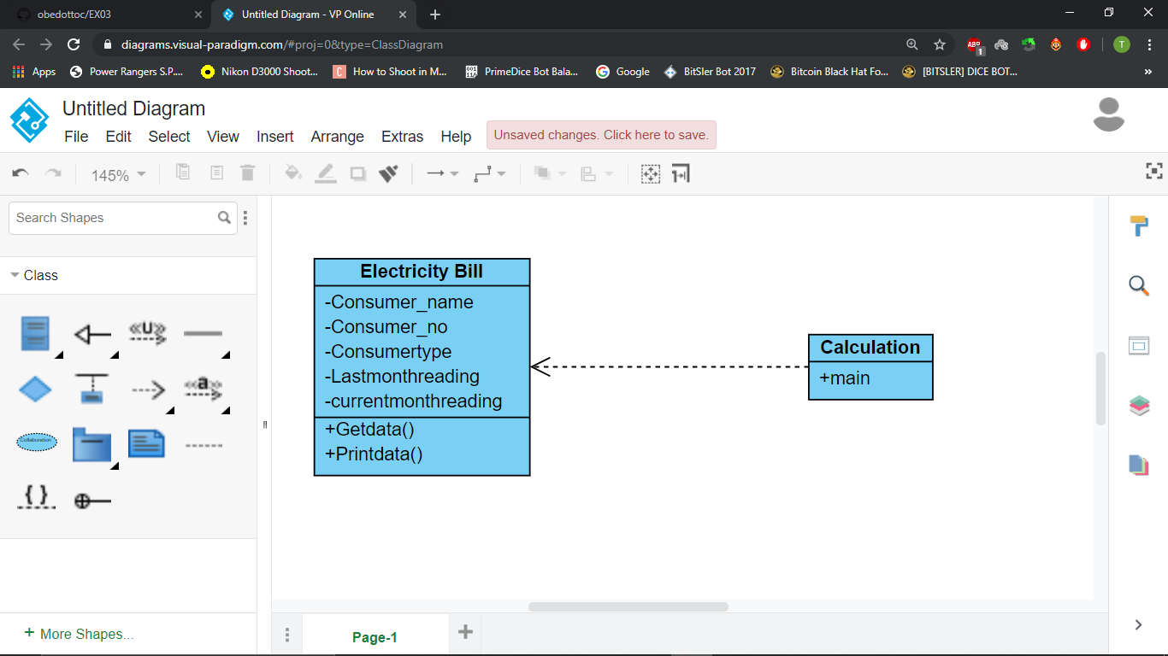

**PROGRAM:**

// created by Akhshy Ganesh B

// program for ELECTRICITY BILL

// Mail ID : akhshyganeshb@gmail.com

**package** Billings;

**import** java.util.Scanner;

**public** **class** Electricitybill

{

**private** String consumer_name;

**private** **int** consumer_no;

**private** String consumertype;

**private** **long** lastmonthreading;

**private** **long** currentmonthreading;

**public** Electricitybill()

{

**this**.consumer_name="ag";

**this**.consumer_no=2334;

**this**.consumertype="domestic";

**this**.lastmonthreading=1456;

**this**.currentmonthreading=1800;

}

**public** Electricitybill(String name, **int** number,String type,**long** lmr,**long** cmr)

{

**this**.consumer_name=name;

**this**.consumer_no=number;

**this**.consumertype=type;

**this**.lastmonthreading=lmr;

**this**.currentmonthreading=cmr;

}

**public** **void** getData()

{

Scanner sc=**new** Scanner(System.***in***);

System.***out***.printf("\n%40s","BILLING INFORMATION");

System.***out***.print("\nEnter the consumer_name:");

**this**.consumer_name=sc.next();

System.***out***.print("Enter the consumer_no:");

**this**.consumer_no=sc.nextInt();

System.***out***.print("Enter the customer type (domestic or commercial):");

consumertype=sc.next();

System.***out***.print("Enter the lastmonthreading:");

lastmonthreading=sc.nextLong();

System.***out***.print("Enter the currentmonthreading:");

currentmonthreading=sc.nextLong();

}

**public** **void** printData()

{

System.***out***.printf("%-40s%40s\n", "Consumer_name:"+consumer_name,"Consumer_no:"+consumer_no);

System.***out***.printf("%s%s %-16s %d\n","Consumertype:",consumertype,"lastmonthreading:",lastmonthreading);

System.***out***.printf("%-40s", "currentmonthreading:"+currentmonthreading);

}

**public** **void** billings()

{

**double** TotalAmount = 0;

**long** unit;

unit=currentmonthreading-lastmonthreading;

String divider="------------------------------------------------";

**if**(consumertype.equals("domestic"))

{

**if**((unit>=0)&& (unit<=100))

{

TotalAmount=unit*1.0;

}**else** **if**((unit>=101)&&(unit<=200))

{

TotalAmount=unit*2.50;

}**else** **if**((unit>=201)&&(unit<=500))

{

TotalAmount=unit*4.0;

}**else**

{

TotalAmount=unit*6.0;

}

}**else** **if**(consumertype.equals("commercial"))

{

**if**((unit>=0)&& (unit<=100))

{

TotalAmount=unit*2.0;

}**else** **if**((unit>=101)&&(unit<=200))

{

TotalAmount=unit*4.50;

}**else** **if**((unit>=201)&&(unit<=500))

{

TotalAmount=unit*6.0;

}**else**

{

TotalAmount=unit*7.0;

}

}

System.***out***.print("\n"+divider+"\n");

System.***out***.print( "BILL");

System.***out***.print("\n"+divider+"\n");

**this**.printData();

System.***out***.print(TotalAmount);

System.***out***.print("\n"+divider+"\n");

}

}

**package** Billings;

**public** **class** calculations {

**public** **static** **void** main(String[] args) {

Electricitybill B1,B2;

B1=**new** Electricitybill("ag",2334,"dosmetic",1456,1800);

B1.printData();

B2=**new** Electricitybill();

B2.getData();

B1.billings();

B2.billings();

}

}

**OUTPUT:**

Consumer_name:ag Consumer_no:2334

Consumertype:dosmetic lastmonthreading: 1456

currentmonthreading:1800

BILLING INFORMATION

Enter the consumer_name:JEFFRY

Enter the consumer_no:2376

Enter the customer type (domestic or commercial):domestic

Enter the lastmonthreading:1500

Enter the currentmonthreading:2000

---------------------------------------------------------------------------------

BILL

---------------------------------------------------------------------------------

Consumer_name:ag Consumer_no:2334

Consumertype:dosmetic lastmonthreading: 1456

currentmonthreading:1800 0.0

---------------------------------------------------------------------------------

---------------------------------------------------------------------------------

BILL

---------------------------------------------------------------------------------

Consumer_name:JEFFRY Consumer_no:2376

Consumertype:domestic lastmonthreading: 1500

currentmonthreading:2000 2000.0

---------------------------------------------------------------------------------

**RESULTS:**

Thus a java console application program is written and the output is verified.